Brazier Mobility
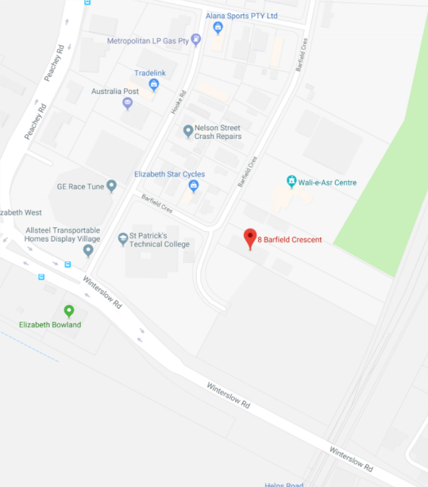
Brazier Mobility (formerly known as Les Brazier Special Vehicles) is an Adelaide based business offering a wide range of services in vehicle conversion, wheelchair accessibility and modified driving controls.
- Personal and commercial vehicles.
- Lifts, hoists and ramps
- Restraint systems
- Seating and transfer fitouts
- Onsite and mobile emergency servicing
- Hand controls
- Steering wheel spinner knobs
- Left foot accelerator pedals
- Power/electric seating
- Indicator modifications
P: 1800 272 943
E: enquiries@braziermobility.com.au
A: 8 Barfield Crescent, Edinburgh North,
South Australia 5113

Willshire
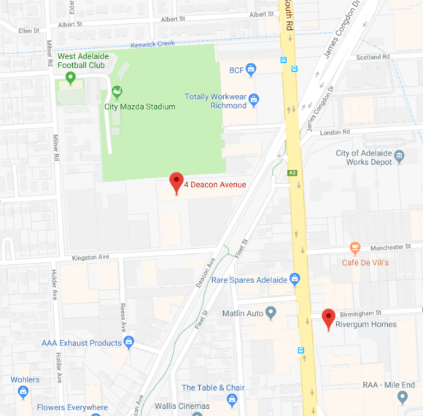
Willshire is a centrally located supplier of disability and mobility vehicle services.
- Wheelchair accessiblity conversions
- Aged care & community bus conversions
- Wheelchair driving aids
- Lifts, hoists & ramps
- Vehicle entry systems and lifts
- Pedal modifications
- Steering devices and spinner knobs
- Behvioural & postural harness
- Seat belt buckle covers

P: 08 8292 2500
F 08 8292 2555
E: sales@willshire.com.au
A: 4 Deacon Avenue, Richmond, South Australia 5033

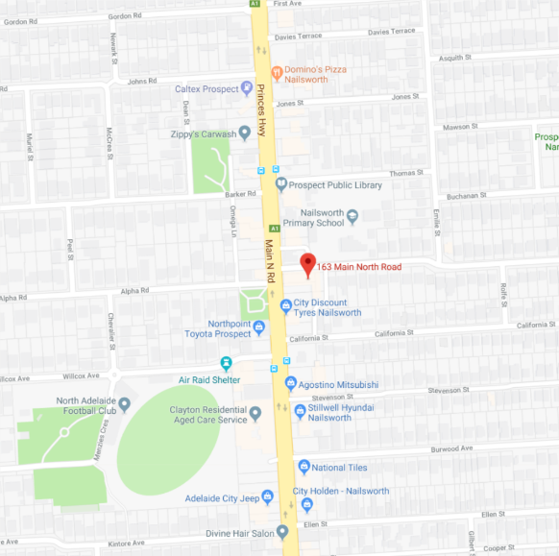
Caddy Storage
Caddy Storage is an Australian manufacturer and supplier of commercial vehicle storage systems and accessories. They have since expanded to offer a variety of driver mobility products and vehicle conversion packages.
- Hand controls
- Seat belts and restraints
- Hand rails
- Seating
- Ramps
- Air suspension
- Entry steps
- Wheelchair hoists
- Driving aids
P: 08 7223 2320
A: 163 Main North Road, Nailsworth, SA 5083
W: https://www.caddystorage.com.au/contact/store-locator/south-australia/

Adelaide Wheelchair Conversions
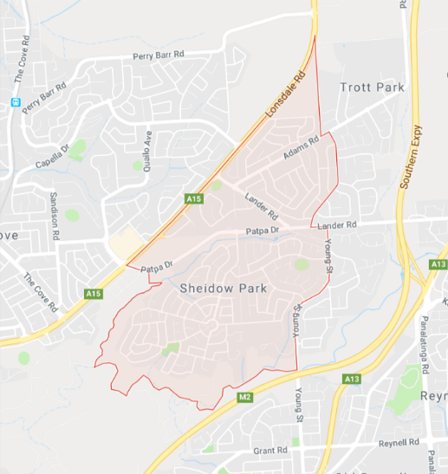
Originally offering wheelchair conversions services to Adelaide taxis, they have since expanded to service individuals with specific vehicle mobility needs. Travelling mobile sales, service and breakdown repair for all brands of wheelchair loaders.
- Vehicle conversions
- Wheelchair lifter installation
- Wheelchair restraints
- Services vehicles of all sizes
- Van fitouts
- Lifter maintenance and repair
- Mobile services
- Access vehicle leasing

P: 0422 130 397
A: Sheidow Park, SA 5158
- Services neighboring suburbs
W: www.mobilityconversions.com.au/contac

CGoodall Engineering
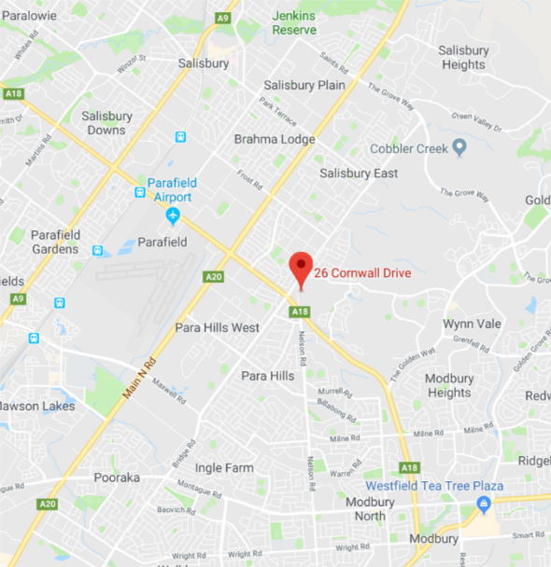
Providing vehicle modifications to people with disability and driver trainers. Specialising in hand controls, wheelchair lifters and more.
- Hand controls - twist grip
- Hand controls - push-pat
- Spinner knobs - manual & electric
- Tail gate wheelchair lifters
- Scooter or wheelchair hoists
- Passenger side break installation
- Motorcycle modifications
- Inspections and approvals
- General metal fabrication
- Wheelchair van conversions
- Left foot accelerators
- Indicator extensions

P: 8250 4008
E: craig@cgoodallengineering.com.au
A: 26 Cornwall Drive, Gulfview Heights, SA,5096

VJ’s Automax
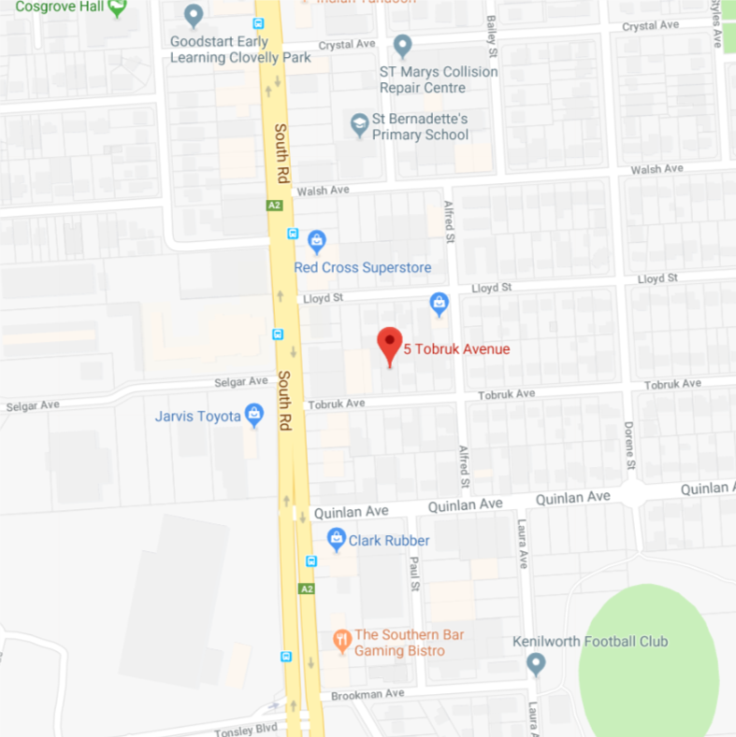
VJ's Automax is situated in the Northern Adelaide suburbs but services customers across South Australia.
- Mechanical services
- Wheelchair lift repairs
- Wheelchair conversions
- Tyre sale & service

P: 0422 227 846
E: vijayk@live.com.au
W: https://www.facebook.com/VjsAutomax
A: 5 Tobruk Avenue, St Marys, South Australia 5042
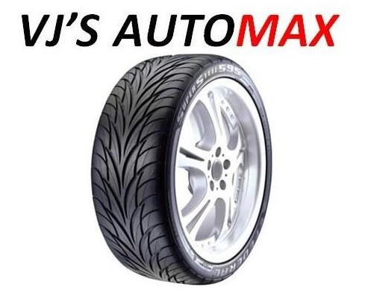

Williams Occupational Therapy
Williams Occupational Therapy offer driver training, vehicle control modification and access conversions. They also offer already experienced drivers with driving aids the opportunity to review their vehicle and have it updated. Bookings by appointment only.

- Pedal alterations
- Hand controls
- Steering aids
- Indicators and secondary controls
- Seatbelts and restraints
- Visual aids
- Vehicle access to drivers or passengers side
- Vehicle access for vans
- Scooter and wheelchair hoists and stowage
- Access steps and grab rails

P: 0466 592 891
F: 08 8311 1744
E: admin@williamsot.com
A: PO Box 144, Blackwood, SA 5051

All information provided is based on supplier’s web information and is not endorsed by DES Wheelchair and Seating Service.

