Prescriber Name:
Client Name:
Client File No: |  |  |  | Order No: |  |  |  |  | Division: Disability  Domiciliary Care |  |  | Date:
Has screening tool been completed? Yes No |  |  |  |  |  |  |  |  | Is client eligible? Yes No
Specifications: information used to check if a recycled item in stock may be suitable for your client. Please identify any essential features required. (tick and comment as required)
3 wheel 4 wheel
Long wheel base (e.g. Space for legs)
Left controls |  | Right controls |  |  |  |  | Finger controls |  |  |  | Thumb controls
Specific seat (i.e. Contour/recline/adjust)
Specific armrest (i.e. Flip back/adjustable)
Seat belt |  | O₂ carrier |  |  |  |  | Flag |  |  |  | Mirrors (left/right)
Walking stick holder |  |  |  |  |  |  |  | Carry bag |  |  | Basket
Frame holder-type? |  |  |  |  |  |  |  | Other
BASIC DIMENSIONS (mm or inches)
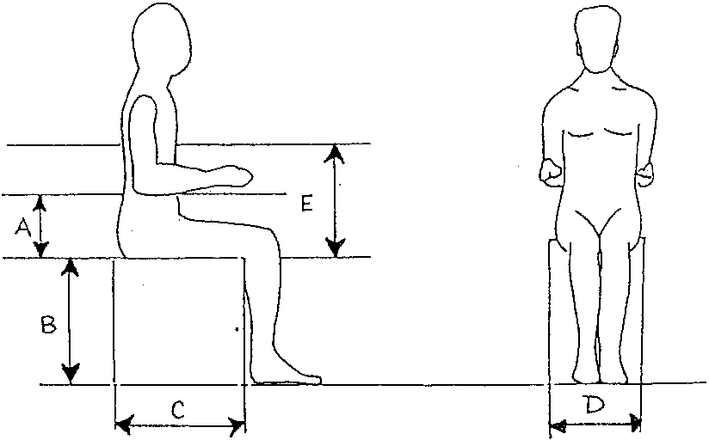

A. Seat - elbow:

B. Back of knee - heel:

C. Buttocks - back of knee:

D. Widest point of hips/thighs:

E. Seat - base of scapula:

Additional Information: (custom seating, cushions, other measurements, accessories, preferences etc)
The information contained in this facsimile transmission may be confidential and may also be the subject of legal professional privilege or public interest immunity. If you are not the intended recipient, any use, disclosure, or copying of this document and/or its attachments is unauthorised. If you have received this document in error, please telephone (08) 8193 1232

