Product Name | Minuet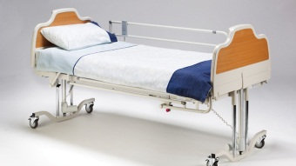 | Arminia II 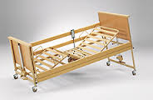 | Melanie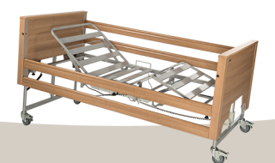 | Etude Plus  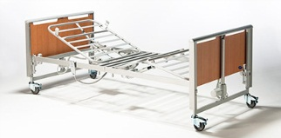
Manufacturer | Arjo Huntleigh | Burmeir | Betten Malsch | Invacare
Availability through DES | refurbished only | refurbished only | purchase* or refurbished | purchase* or refurbished
DES Code | AB01I A | AB01O A | AB01P A | AB01T A
SWL capacity  NB: allow approx. 40kg for mattress & bedding | 180kg | 175kg | 175kg | 200kg
Features | head raise,  knee bend,  manual leg raise  Trendelenburg  reverse Trendelenburg | head raise,  knee bend,  leg raise manual,  Trendelenburg  (some have reverse Trendelenburg) | head raise,  knee bend,  leg raise manual,  Trendelenburg  reverse Trendelenburg | head raise,  knee bend,  leg raise manual,  Trendelenburg  reverse Trendelenburg
Total bed footprint (W x L) | 920 x 2200 | 1030 x 2200 | 1050 x 2130 | 1020 x 2200
Height range | 220 - 630 | 400 - 800 | 400 - 800 | (standard) 410 – 810  OR 340 -740
Clearance under bed | clear | clear | clear | clear
Backrest platform length | 760 | 750 | 700 | 850
Backrest angle | 0° - 73° | 0° - 70° |  | 0° - 70°
Internal platform dimensions (W x L) | 920 x 2040 | 890 x 2050 | 890 x 2000 | 890 x 2080
Lockable handle controller? | no | no | yes | optional
Mattress retainers? | Side (head end)  Foot end | Sides | no | yes, can rotate away
Width between retainers | 870 (width)  2000 (length) | 850 | n/a | 850
Bed extension available? | no | yes – 150mm | no | yes – 200mm
Self-help pole position | 90mm in from headboard  70mm from side railing | 75mm in from headboard  70mm from side railing | n/a | 80mm in from headboard  60mm from side railing
Other notes |  |  |  | Not suitable for <12yo

Minuet
Bed Rail Options and Specifications
Style | 3/4 length |  |  |  |  | 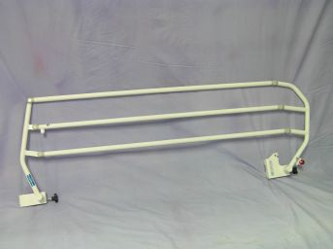
DES Code | AB09G A
Internal gaps within rails | 120
Distance between left and right bed rails | 980
Rail height from bed platform | 395
Rail cover options | Padded – ABO9I A |  |  |  |  | 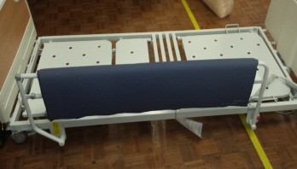

Information on Mattress Requirements
Configuration | Max. Height |  | Max. Width  (no side retainers) |  |  | Max. Width  (side retainers) |  | Max. Length
no rails | n/a |  | 920 |  |  | 870 |  | 2000
3/4 rails | 175 |  | 940 |  |  | 870 |  | 2000
Potential Suitable Mattresses |  | NB: does not indicate entrapment zone compliance
Product Name |  | DES Code |  |  | Equip. Program Category |  | Mattress Dimensions  (W x L x H) | Rail Options
Mattress Hospital Bed MSS Premier Glide |  | AB14J A |  |  | Cat 1 |  | 870 x 1960 X 150 | ¾ rails
Zenith PM265 Mattress Overlay |  | AB15AA A |  |  | Cat 1 |  | 900 x 2000 x 127 (+100 mm underlay) | no rails
Zenith PM268 Mattress Replacement System |  | AB15AB A |  |  | Cat 1 |  | 900 x 2000 x 200 | no rails

Arminia II
Bed Rail Options and Specifications
Style | Full length
DES Code | n/a (ordered with bed)
Internal gaps within rails | 150
Distance between left and right bed rails | 940
Rail height from bed platform | 385
Rail cover options | full length - AB09N A |  |  |  | 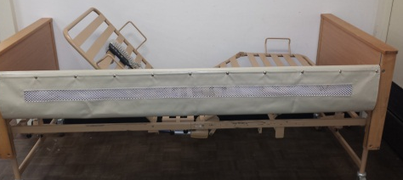
Information on Mattress Requirements
Configuration | Max. Height | Max. Width  (no side retainers) |  |  | Max. Width  (side retainers) | Max. Length
no rails | n/a | 900 |  |  | 850 | 2010
Full length rails | 165 | 900 |  |  | 850 | 2010
Potential Suitable Mattresses |  | NB: does not indicate entrapment zone compliance
Product Name |  | DES Code |  | Equip. Program Category | Mattress Dimensions  (W x L x H) | Rail Options
Mattress Hospital Bed MSS Premier Glide |  | AB14J A |  | Cat 1 | 870 x 1960 X 150 | Full length
Mattress ROHO 4 Sections Includes Cover |  | AB15F A |  | Cat 1 | 860 x 2030 x 80 | Full length
Zenith PM265 Mattress Overlay |  | AB15AA A |  | Cat 1 | 900 x 2000 x 127 (+75mm underlay) | Full length
Zenith PM268 Mattress Replacement System |  | AB15AB A |  | Cat 1 | 900 x 2000 x 200 | Full length

Etude Plus
Bed Rail Options and Specifications
 | Scala Basic 2 |  |  | Full length
 | 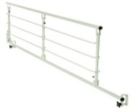 |  |  | 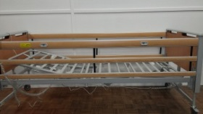
DES Code | AB09J A |  |  | AB09F A  AB09Q A (extended length rails)
Internal gaps within rails | 100 |  |  | 100
Distance between left and right bed rails | 910 |  |  | 955 - 970
Rail height from bed platform | 390 |  |  | platform at lowest setting: 440  platform at highest setting: 370
Rail cover options | 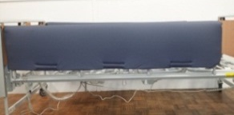  Padded – AB09K A |  |  | 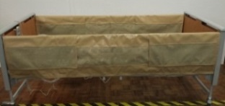  Mesh - AB09O A; AB09S A (for extended length rails)
Padded - AB09P A; AB09R A (for extended length rails)
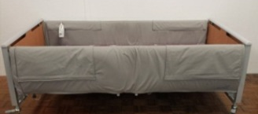
Information on Mattress Requirements
Configuration | Max. Height |  | Max. Width  (no side retainers) |  |  | Max. Width  (with side retainers) | Max. Length
no rails | n/a |  | 900 |  |  | 850 | 2040
Scala Basic 2 | 170 |  | 880 |  |  | 850 | 2040
Full length rails | lowest setting: 220  highest setting: 150 |  | 900 |  |  | 850 | 2040
Potential Suitable Mattresses |  | NB: does not indicate entrapment zone compliance
Product Name |  | DES Code | Equip. Program Category |  | Mattress Dimensions  (W x L x H) |  | Rail Options
Mattress Hospital Bed MSS Premier Glide |  | AB14J A | Cat 1 |  | 870 x 1960 X 150 |  | all
Zenith foam mattress - narrow |  | AB14O A | Cat 1 |  | 840 x 2020 x 150 |  | all
Mattress Platinum Foam |  | AB14Q A | Cat 1 |  | 880 x 2020/2040 x 150 |  | all
Mattress ROHO 4 Sections Includes Cover |  | AB15F A | Cat 1 |  | 860 x 2030 x 80 |  | all
Zenith PM265 Mattress Overlay |  | AB15AA A | Cat 1 |  | 900 x 2000 x 127 (+75mm underlay) |  | Full length
Zenith PM268 Mattress Replacement System |  | AB15AB A | Cat 1 |  | 900 x 2000 x 200 |  | Full length
Mattress Overlay AlphaXcell |  | AB15T A | Cat 2 |  | 840 x 2050 x 120 |  | no rails

