Prescriber Name:
Date: | Client File No:
Client Name:
This information is used to check if a recycled item in stock may be suitable for your client.
Please identify any essential features required.
Manual Wheelchair Type:  1. Basic  2. Customised Folding  3. Rigid  4. Tilt/Recline |  |  |  | Powered Wheelchair Type:  1. Basic  2. Standard RWD/MWD  3. Power Tilt  4. Power Tilt and Recline
Manual: Rigid Transit Folding  Self propel Front wheel drive |  |  |  | Electric: Drive: Rear Wheel Mid wheel  Controls: Left Right
Castors: Solid Air Size mm Drive Wheels: Solid Air Quick release
Frame Recline (power/manual) Tilt in space (power/manual) Amputee
Armrest: Any Desk None Full length Flip up
Leg rest: Swing away One piece Hanger Length: mm
Stump: Left Right Elevating (power/manual) None
Seat to Floor Heights: Front Seat Height: mm Rear Seat Height: mm
Seat Cushion: Width mm Depth mm |  |  |  | Backrest: Height mm
Seat Cushion Type:  1. Basic Foam on Slung Upholstery  2. Pressure cushion eg Air, Gel  4. Customised Seat Cushion eg. Foam on Ply |  |  |  | Backrest / Accessories Type:  1. Off the shelf Accessories eg tray, stump support  3. Modular Backrest / laterals – off the shelf  4. Customised Backrest eg Foam on Ply, Foam in place
Seating Specialist Required? Yes No |  |  |  | Seating Technician Required? Yes No
Growth: adjustment for growth needed? Yes No Describe any other growth considerations:

Additional Information: (custom seating, cushions, other measurements, accessories, preferences etc)

Basic Measurements:  (Must be completed) |  | Left | Right |  | Max Overall Width (internal access etc) mm
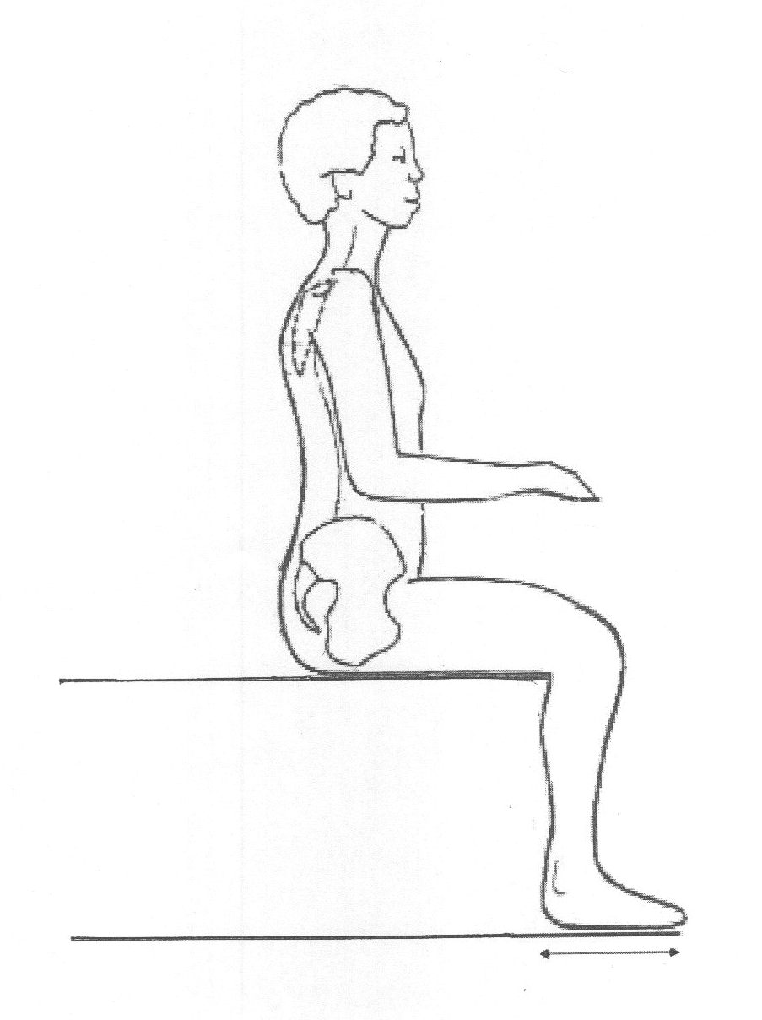
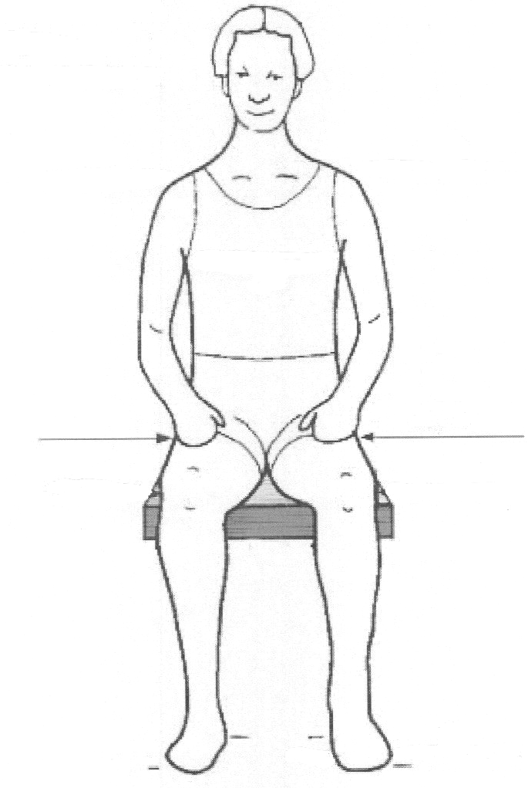
A

G
C
B
F
D
H
E
A | Widest point at hips or thighs:
B | Posterior of buttocks  back of knee
C | Back of knee  heel
D | Seat  base of scapula (Manual type 1-3)
E | Seat  top of shoulder (PWC, Type 4 Manual)
F | Seat  elbow
G | Chest Width (PWC, Type 4 Manual):
H | Axilla Height (PWC, Type 4 Manual)
Height: |  | Weight:
The information contained in this facsimile transmission may be confidential and may also be the subject of legal professional privilege or public interest immunity. If you are not the intended recipient, any use, disclosure, or copying of this document and/or its attachments is unauthorised. If you have received this document in error, please telephone 1300 295 786

