

**DFC Equipment Program:** Adults

**Mobile shower / commode chair assessment form**



| Client name: | |  | | Sex:  M  F | | | DOB: | |  | |
| --- | --- | --- | --- | --- | --- | --- | --- | --- | --- | --- |
| Address: |  | | | | | Phone No: |  | | | |
| Clinician: |  | | Agency: | |  | | | Date: | |  |

| **MEDICAL HISTORY** Dx/prognosis: |  | | | | |
| --- | --- | --- | --- | --- | --- |
|  | | | | | |
|  | | Height: |  | Weight: |  |

| **EQUIPMENT CURRENTLY USED** |
| --- |
|  |

**PHYSICAL STATUS**

| Skin history/integrity *(note areas of present and past breakdown)*: | | | | |  | |
| --- | --- | --- | --- | --- | --- | --- |
|  | | | | | | |
| Spasticity/tremor *(note when it occurs, how it affects function)*: | | | |  | | |
|  | | | | | | |
| Upper limb function: | |  | | | | |
|  | | | | | | |
| Lower limb function: | |  | | | | |
|  | | | | | |  |
| Balance/trunk control *(static and dynamic)*: | | |  | | | |
| Period of Use: | | | | | | |
| Sitting posture: |  | | | | | |

## FUNCTIONAL STATUS

| **Mobility:** Ambulation status: | | |  | |
| --- | --- | --- | --- | --- |
| Mobile shower/commode chair use: | | | | Independent  Assisted  Dependent |
| Style:  Large front wheel drive  Large rear wheel drive  Transit | | | |
| Comments: | |  | | |
| Period of Use: | | | | |

| **Transfers:** Equipment/aids currently used: | | |  | | |
| --- | --- | --- | --- | --- | --- |
| Floor surface: | |  | | Bed height: |  |
| Comments: |  | | | | |
|  |  | | | | |
|  |  | | | | |
|  |  | | | | |

###### Toileting

| Toilet access *(note doorway width)*: | | | | |  | | |
| --- | --- | --- | --- | --- | --- | --- | --- |
| Transfers: | | On/off toilet | Equipment/aids used: | | | |  |
| Mobile shower chair over toilet | | | Toilet in bathroom?  Yes  No | | | |
| Used as a commode/pan required?  Yes  No | | | | | |  | |
| **IF SHOWER CHAIR IS CUSTOMISED AND NEEDS TO GO OVER TOILET, PLEASE COMPLETE TOILET MEASUREMENT FORM** | | | | | | | |
| Comments: | |  | | | | | |
|  | | | | | | | |

###### Showering

| Bathroom access: *(note doorway width, standard = 800mm.)* | | | | | | | | | | | | |  | | | | | | |
| --- | --- | --- | --- | --- | --- | --- | --- | --- | --- | --- | --- | --- | --- | --- | --- | --- | --- | --- | --- |
| Shower access: *(note doorway width, hob, platform required etc)* | | | | | | | | | | | | | | |  | | | | |
| Shower access modifications required: | | | | | | | | Yes  No | | | | | |  | | | | | |
| Personal care tasks:  Independent  Assisted  Dependent | | | | | | | | | | | | | | | | |  | | |
| Personal care service provided: | | | | | | Yes  No | | | | |  | | | | | | | | |
| Grab rails: | | Present  Not required  Required | | | | | | | | | | | | | | Height: | |  | |
| Hand-held shower hose: | | | Present  Not required  Required | | | | | | | | | | | | | | | Attachment height: |  |
| Electrical safety assessed: | | | | Yes  No | | | | |  | | | | | | | | | | |
| Electrical safety action taken: | | | | | Yes  No | | | | |  | | | | | | | | | |
| Service plan updated as indicated: | | | | | | | Yes  No | | | | |  | | | | | | | |
| Comments: |  | | | | | | | | | | | | | | | | | | |
|  | | | | | | | | | | | | | | | | | | | |

## CLIENT GOALS and CONCERNS

| Period of Use: |
| --- |
|  |
|  |

## ADDITIONAL NOTES/SUMMARY

| Period of Use: |
| --- |
|  |
|  |

| **Clinician’s Name** |  | | |
| --- | --- | --- | --- |
| **Clinician’s signature:** |  | **Date:** |  |

**MOBILE SHOWER/COMMODE CHAIR SPECIFICATION SHEET**

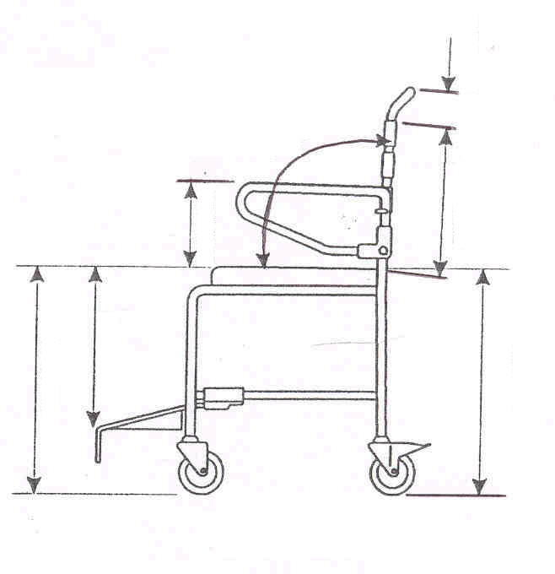

_______

_______

_______

_______

_______

_______

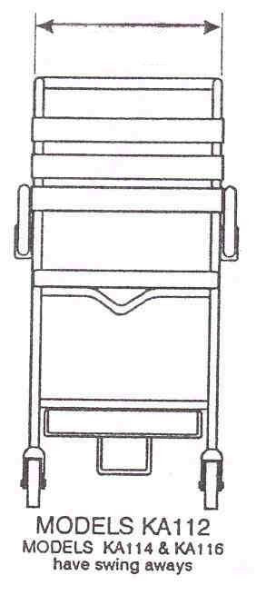

_______

_______

_______

_______

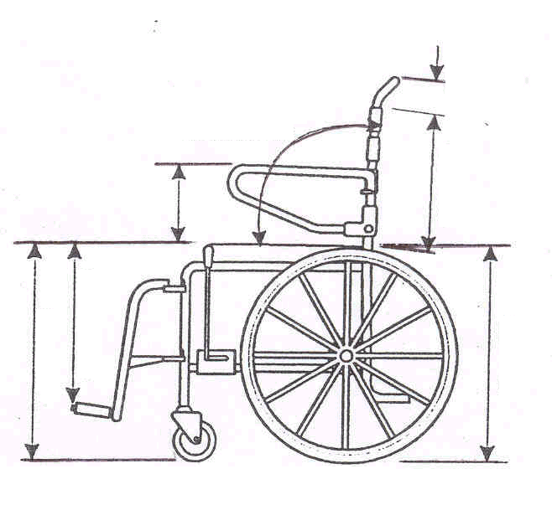

_______

_______

_______

_______

_______

_______

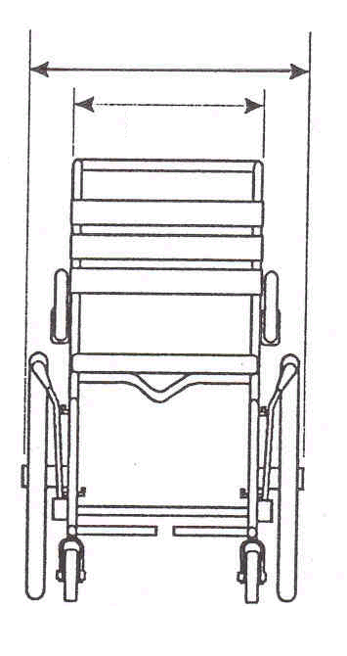

_______

| **Seating 0ptions:** | | | **Seat Depth:** | | | | | | |  | | | | | | | | | | | **Seat Width:** | | | | | | | | |  | | | | |
| --- | --- | --- | --- | --- | --- | --- | --- | --- | --- | --- | --- | --- | --- | --- | --- | --- | --- | --- | --- | --- | --- | --- | --- | --- | --- | --- | --- | --- | --- | --- | --- | --- | --- | --- |
|  | | | Curved, fixed, padded back | | | | | | | | | Back rest height (std 365mm) | | | | | | | | | | | | | | | | | | | Headrest | | | |
|  | | | Tie on seat/back | | | | | | Extra seat padding | | | | | | | | | | | Pommel | | | Back rest extension (std) | | | | | | | | | | |
|  | | | Open front seat | | | | | Rear open seat | | | | | | | Hand padded seat | | | | | | | | | | | | | Reinforced seat base | | | | | | |
|  | | | Right side opening  Left side opening | | | | | | | | | | | | | Standard seat | | | | | | | | | | | Pelvic/seat belt | | | | | | | |
|  | | | Hand padded seat  Custom hole size | | | | | | | | | | | | | Back rest height (std 365) | | | | | | | | | | | | | | | |  | | |
| **Frame option:** | | | Tilt-in-space | | *Hydraulic* *Mechanical* | | | | | | | | | | | | | Forward tilt | | | | | | | | | | |  | | | | | |
|  | | | Custom recline | | | |  | | | | | | | | | Custom tilt | | | | | | | |  | | | | | | | | | | |
|  | | | Self propel | | | Transit | | | | | | | 4 locking castors | | | | | | | | | 2 locking castors | | | | | | | | | | | | |
| **Armrest options:** | | | Folding safety bar | | | | | | Lock down arms | | | | | | | | Padded vinyl armrest | | | | | | | | | | | | | | | | | |
|  | | | Drop-side arms | | | | | | Removable arms | | | | | | | | Gutter supports  Flip up arms | | | | | | | | | | | | | | | | | |
| **Lower body options:** | | | | Stump support | | | | | | | Aluminium footplates | | | | | | | | | | | | | | | Elevating leg rests | | | | | | |
|  | | | | Calf strap/pads | | | | | | | Neoprene foot plate covers | | | | | | | | | | | | | | Removable footplates | | | | | | | |
|  | | | | One piece footplate | | | | | | | Two piece footplate | | | | | | | | | | | | | | Flip up footplate | | | | | | | |
|  | | | | Sliding footplate | | | | | | | Height adjustable footplates | | | | | | | | | | | | | | | Swing away footplate | | | | | | |
| **Other accessories:** | | | | IV pole | | | | | | | Oxygen bottle carrier | | | | | | | | | | | | | | | Push handles | | | | | | |
|  | | | | Anti-tip bars | | | | | | | Front/Back castor extension | | | | | | | | | | | | | | | Brake extension levers | | | | | | |
|  | | | | Pan & carrier | | | | | | | Push on brakes | | | | | | | | | | | | | | | Pull on brakes | | | | | | |
|  | | | | Extended back rest | | | | | | | Chest harness | | | | | | | | | | | | | | | Foot straps/cups | | | | | | |
|  | Head rest (this is compulsory with TIS) | | | | | | | | | | | | Other | | | | |  | | | | | | | | | | | | | |
| **Details:** | |  | | | | | | | | | | | | | | | | | | | | | | | | | | | | | | |
|  | |  | | | | | | | | |  | | | | | | | | | | | | | | |  | | | | | | |
|  | |  | | | | | | | | |  | | | | | | | | | | | | | | |  | | | | | | |
|  | | | | | | | | | | | | | | | | | | | | | | | | | | | | | | | | |
|  | | | | | | | | | | | | | | | | | | | | | | | | | | | | | | | | |
|  | | | | | | | | | | | | | | | | | | | | | | | | | | | | | | | | |
|  | | | | | | | | | | | | | | | | | | | | | | | | | | | | | | | | |
|  | | | | | | | | | | | | | | | | | | | | | | | | | | | | | | | | |
|  | | | | | | | | | | | | | | | | | | | | | | | | | | | | | | | | |
|  | | | | | | | | | | | | | | | | | | | | | | | | | | | | | | | | |
|  | | | | | | | | | | | | | | | | | | | | | | | | | | | | | | | | |
|  | | | | | | | | | | | | | | | | | | | | | | | | | | | | | | | | |
|  | | | | | | | | | | | | | | | | | | | | | | | | | | | | | | | | |

**🞶 PLEASE ATTACH FURTHER DIAGRAMS AND DETAILS IF REQUIRED**

| **Clinician’s Name:** |  |  |  |
| --- | --- | --- | --- |
| **Clinician’s Signature:** |  | **Date:** |  |